System Requirements

Template

Version 1.0 - Oct 13, 2017

Contents

Section 1 Purpose 3

Section 2 General System Requirements 3

2.1 Major System Capabilities 3

2.2 Major System Conditions 3

2.3 System Interfaces 3

2.4 System User Characteristics 3

Section 3 Policy and Regulation Requirements 4

3.1 Policy Requirements 4

3.2 Regulation Requirements 4

Section 4 Security Requirements 4

Section 5 Training Requirements 4

Section 6 Initial Capacity Requirements 4

Section 7 Initial System Architecture 5

Section 8 System Acceptance Criteria 5

Section 9 Current System Analysis 5

Section 10 References 6

Section 11 Glossary 6

Section 12 Document Revision History 6

Section 13 Appendices 6

# Section 1 Purpose

The purpose of the System Requirements document is to specify the overall system requirements that will govern the development and implementation of the system. The document will also establish initial security, training, capacity and system architecture requirements.  
  
The purpose of this document is to give a detailed description of the requirements for the “Facebook Searcher” Desktop software It will illustrate the purpose and complete declaration for the development of system. It will also explain system constraints, interface and interactions with other external applications. This document is primarily intended to be proposed to a customer for its approval and a reference for developing the first version of the system for the development team.  
  
The facebook searcher is a desktop application that help the user to search for people on facebook by name and by specific location . if the user enter a name for example “ahmed” then all the users on facebook that their first name is ahmed will appear in a listbox and if the user searched by specific location for example “semouha, Alexandria ,Egypt ” will bring to him all the facebook users that live in this place.

# Section 2 General System Requirements

## 2.1 Major System Capabilities

*Specify the major system capabilities in terms of availability, target deployment environment(s), device accessibility, and/or technical capability.*

* *System must be available 24 hours per day*

## 2.2 Major System Conditions

*Specify major system assumptions and/or constraints (aka conditions). The conditions may limit the options available to the designer/developer. For example:*

*- System must use the .NET Framework*

## 2.3 System Interfaces

*Describe the dependency and relationship requirements of the system to other enterprise/external systems. Include any interface to a future system or one under development. For clarity, a graphical representation of the interfaces should be used when appropriate.*

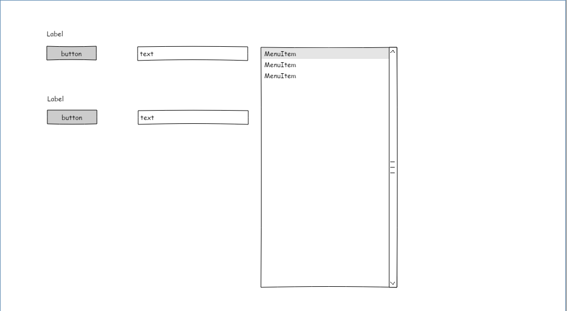

## 2.4 System User Characteristics

*Identify each type of user of the system by function, location, and type of device. Specify the number of users in each group and the nature of their use of the system.*

# Section 3 Policy and Regulation Requirements

*Specify relevant applicable laws, regulations, policies, and standards that will affect the operation and performance of the system, as well as any relevant external regulatory requirements, or constraints imposed by normal business practices.*

## 3.1 Policy Requirements

## 3.2 Regulation Requirements

# Section 4 Security Requirements

*Specify security requirement for users of the system.*

$$⇒$$

# Section 5 Training Requirements

# Section 6 Initial Capacity Requirements

1. *Identifies the highest and lowest estimated number of transactions and processing frequency expected usage (including any seasonal peaks) for capacity planning for storage and memory requirements for the application or project.*

# Section 7 Initial System Architecture

*Specify the data platform, hardware, software, programming languages, tools and operating system requirements for the application or project.*

1. *64 bit windows plate form*
2. *.Net Framework*
3. *C#*
4. *Facebook API*

# Section 8 System Acceptance Criteria

*Specify the general system acceptance criteria specified and agreed upon by the project sponsor and key stakeholders that will be used to accept the final end product. For example:*

* *New system must run in parallel with current production system for x months*
* *3 years of data must be in system (conversion implied) on day one*

# Section 9 Specific Requirements

9.1 User Interface  
 the interface must contain two text boxes one for searching name and the other for

searching by location and a Search button and a List box for the result